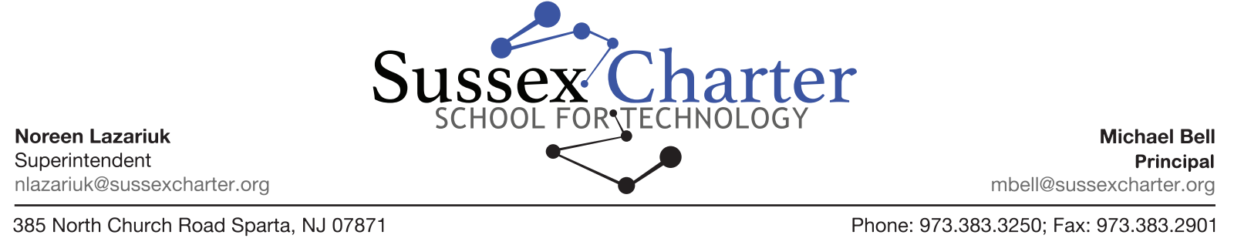

Dear Parents and Guardians,

Every year the following health forms must be filled out by a parent or guardian for each Sussex Charter student.

1. **Student Emergency Information**
2. **Student Health History**
3. **Medication Dispensing Form**

Kindly return the completed forms to school as soon as possible.

Please note that in addition to filling out the forms listed above, all new students are required to have a physical before entering school. Please have your health care provider send a copy to school as soon as possible.

If you have any questions or concerns, please feel free to contact me.

Thank you,

Christine Larco, BSN, RN-C

[christine.larco@sussexcharter.org](mailto:christine.larco@sussexcharter.org)

Phone: (973) 383-3250 Ext. 2

Fax: (973) 383- 2901